

Software Engineering 4 year

CALCULATOR && TIMER ASSIGMENT

Lecture: Earl Gaylard

Student: Lyu Zheng A00248564

Subject:CLIENT-SIDE TECHNOLOGIES

Assignment report

1. Calculator

The interface of calculator:



First,this is the html for the interface, it is to make the buttons and screen for the calculator,

<a href> point to the functions and set the id for all the buttons

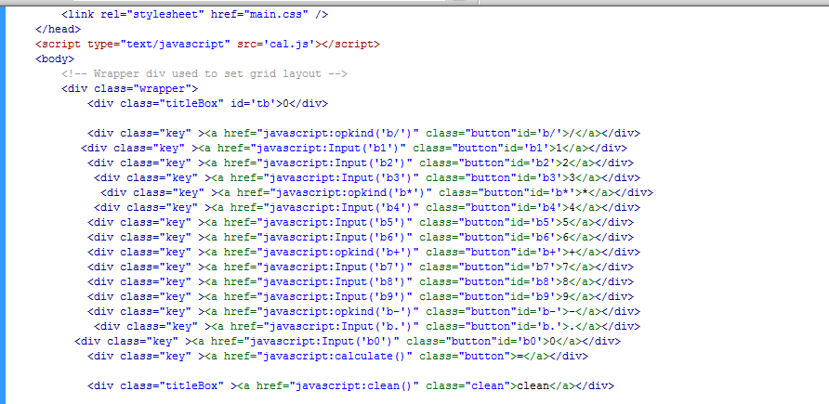

Identify some variate, and create a function to input the value

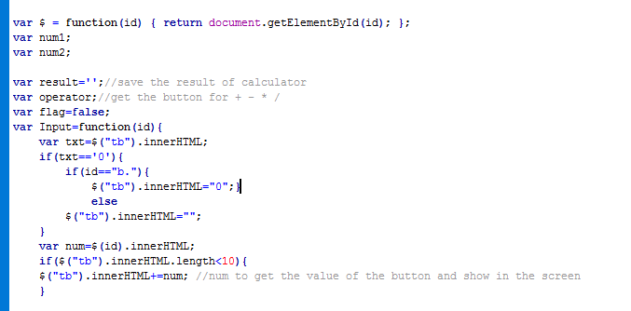

The num1 and num2 is to get the value you inputted, operator is to get the operational character you inputted(+ - \* /). The flag is for the judgement in the calculation. The input function is to show the number that you inputted in the screen. At first it will show a 0 on the screen, the judgement is to cover the 0 after you input some value.The number on the screen can not more than 10.

This function is for operational characters, after click a operational character ,the num1 will save the value you input for the first time,the flag become true and clear the screen

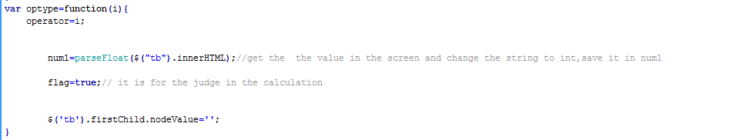

The calculator function will divide to three parts,the first part is when you click the equal for the first time. The num2 save the value after the operational character and calculate the result,show it on the screen. There will be a message to warn you that the divider can not be “0” if you divided 0.

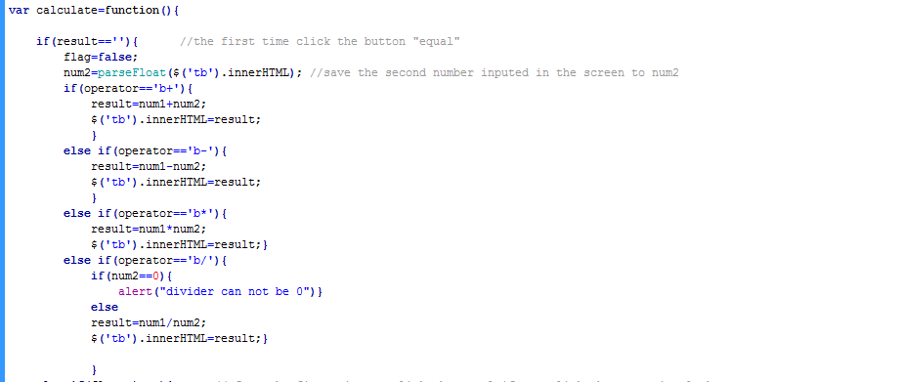

This is the second part for calculate function. After the first time to click the equal,if you click the operational character, the calculator will calculate the next result base on the first result.

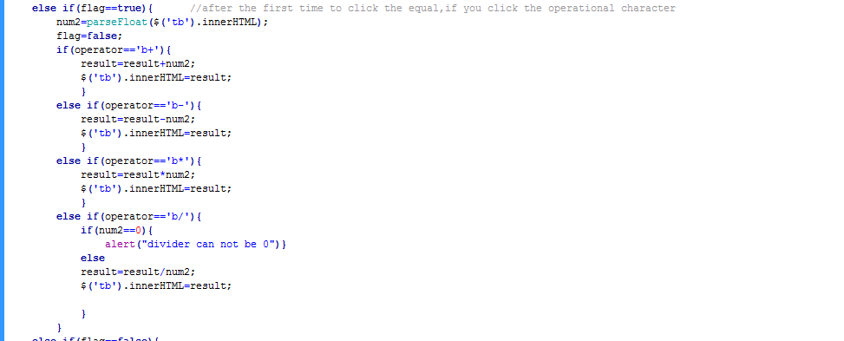

This is the last part.After the time to click the equal,if you continue to click equal,it can calculate the value by the last clicked operational character.For example,if you calculate (2+2=4),and you click “=” after that, that means(4+2=6),the result will be 6. The flag is to judge whether you click operational character or equal after one calculation finished.

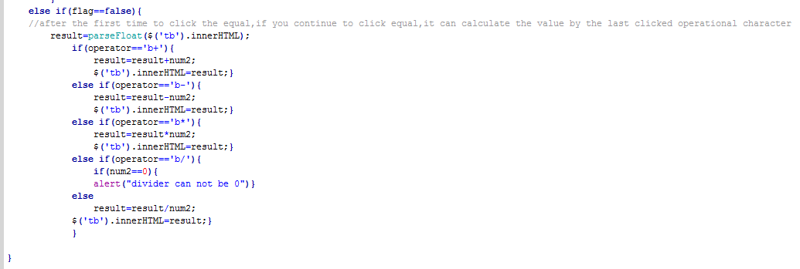

This is for css(the css should be effective on chrome)

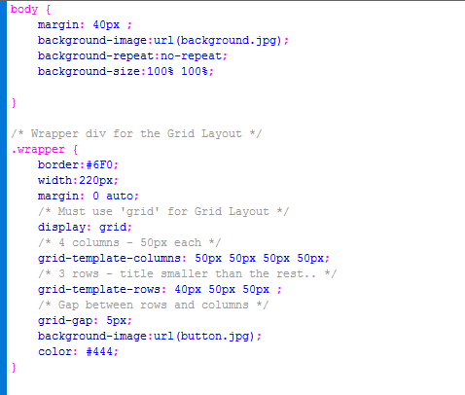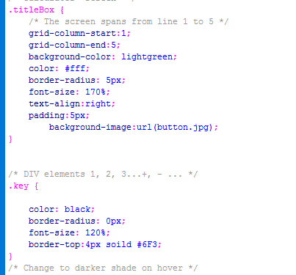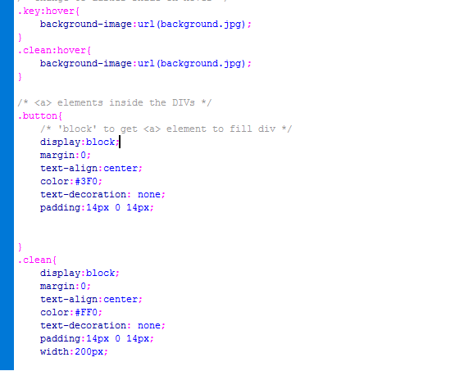

Part2 Race Timer

This is the interface

Start-->record-->reset-->clear

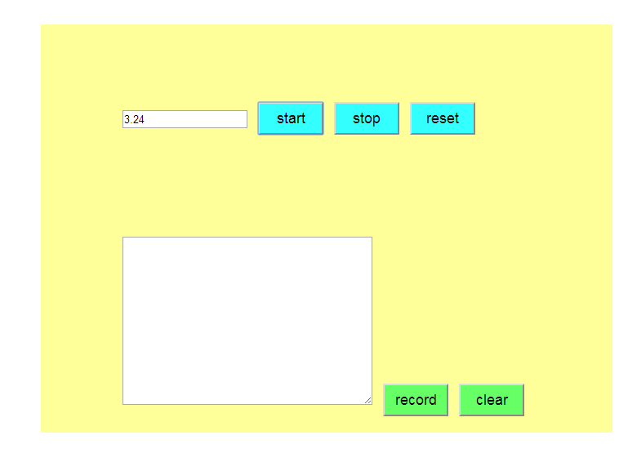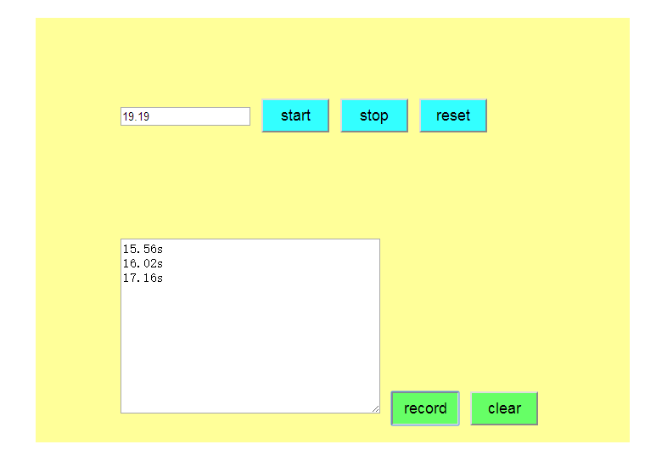

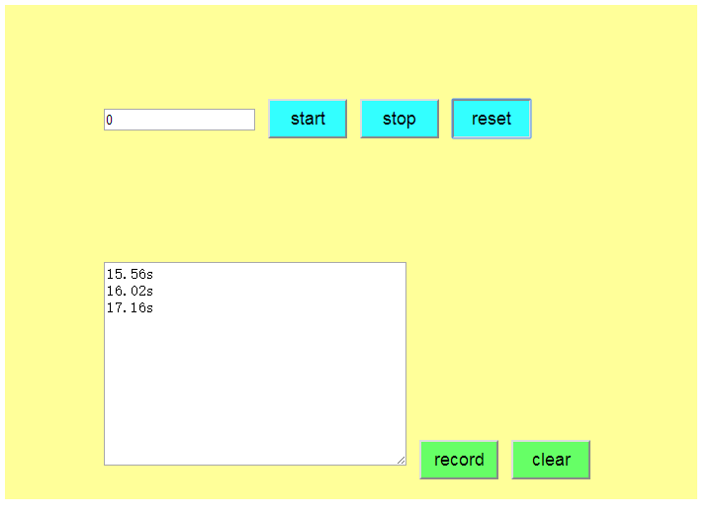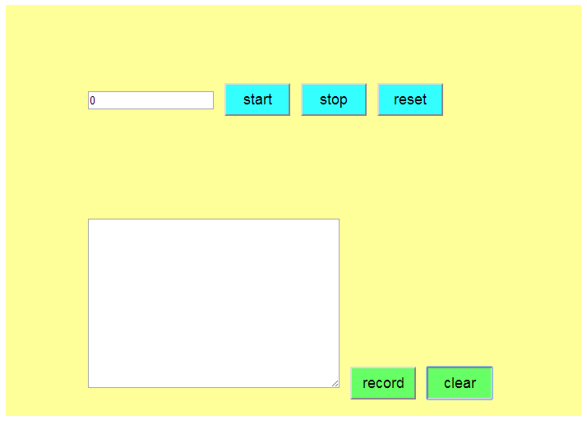

This is the form. I defined five buttons and text and textarea

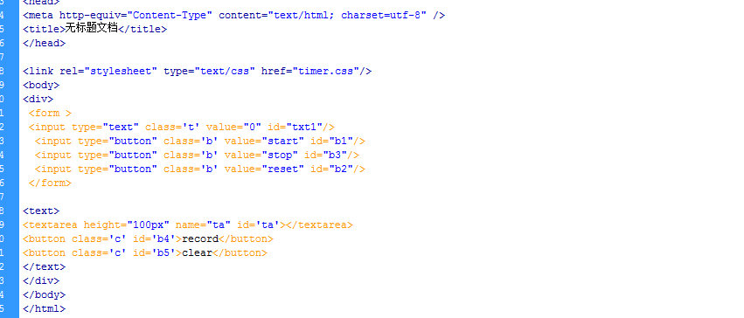

Get the id for every control widget, set id to define the timer and seed as the second clock.

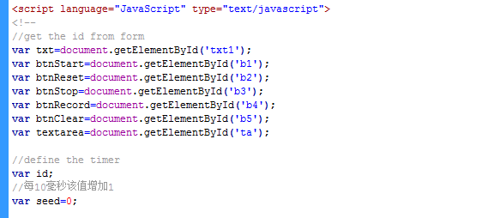

If you click the start button,it will begin to execute tip function every 0.01 second

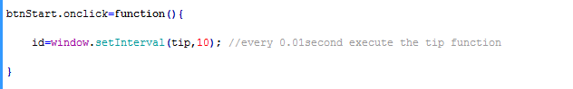

The tip function will add the seed every 0.01s and show seed/100 on the text, as a second clock

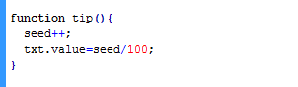

The stop button is to stop the Interval function,which means the second clock will be stopped



If you click the reset button, the seed will become 0 and the text will clear to 0

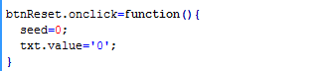

The record button will record the date in the textarea, and clear button to clear the date.

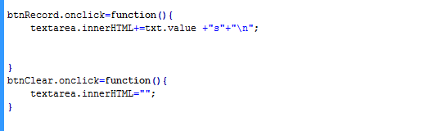

This is for css

